Strings

Strings are objects.just like other objects you can create a string object using aa new keyword.

String s=new String();

A new string object is created and assigned to the reference variable s.

Lets give string some value:

s=”abcdefg”;

Another way of creating strings:

| String s=new String();  s=”abcd”; |  |
| --- | --- |
| String s=”abcd” |  |
| String s=new String(“abc”); |  |
| String s2=s; | A second reference variabel which refer to |

Once you have assigned a string a value ,that value can never change-its immutable

The string object is immutable but the reference variable is not.

s=s.concat(“hello”);

Since strings are immutable so the vm made a new String object and made our object s refer to it.

 

s was previously referring to

“abc” but now referring to “abc new”

There will be three strings in the scp.but we will have reference to only abc new”

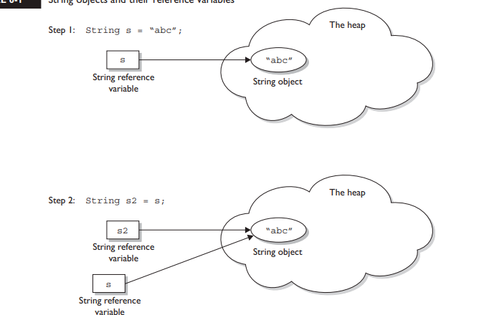

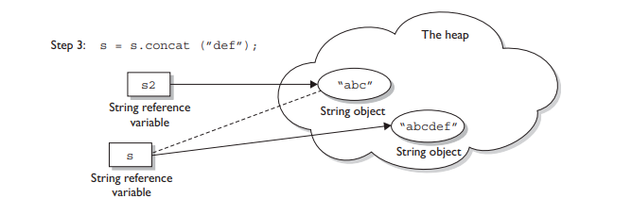

Example 2

String x=”Java”;

x.concat(“Rules”);

System.out.println(x);

Output will be x=Java.Since the new string Java Rues is not referred by any variable.

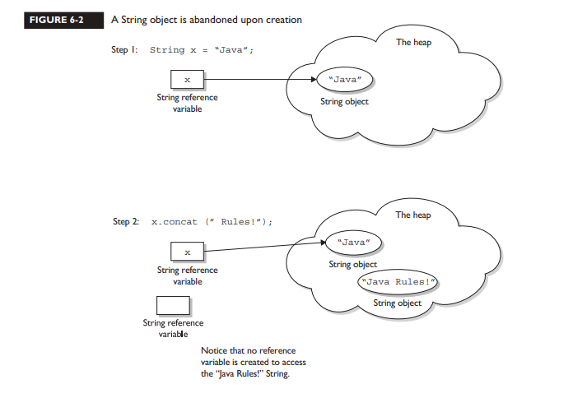

**Example 3**

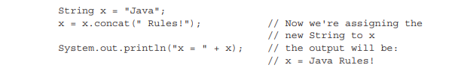

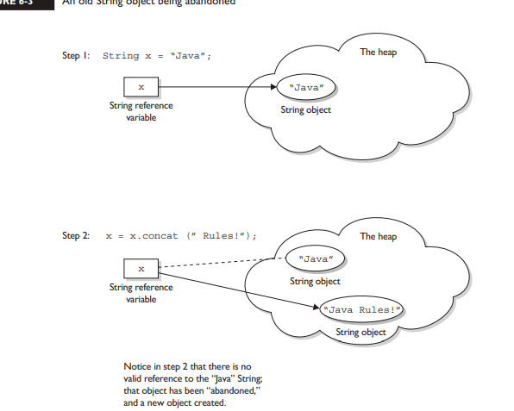

EXAMPEL 4

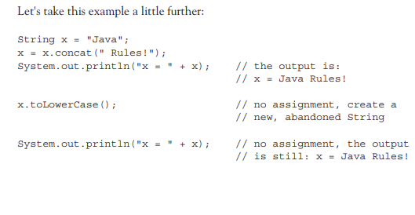

**EXAMPLE 5**

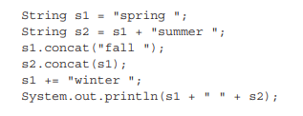

**STRING CONSTANT POOL**

To make java more memory efficient the jvm sets aside a special area in memory called the string constant pool.

When the compiler encounters a string literal ,it checks pool to see if an identical Sting is already present , then the reference of new string is referred tot he existing constan tin the pool no new object is created.

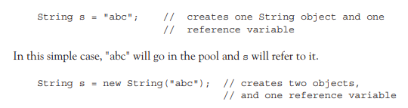

**String buffer and Strin Builder**

Strign builder class was added in java5;

Stringbuilder is not thread safe.

It is recommended to use Stringzbuilder whenever needed since String builder runs faster